***2nd week assignment***

**1)We must create a VM for Windows by adding the custom data in the advanced section for Node.js file.**

We have to create a virtual machine; I named it as Dedeepya.

Open putty and connect it by pasting the IP address.

now open the bash script and put the below code and run the command “nohup nodejs index.js &”

**Code:**

var express = require('express')

var app = express()

var os = require('os');

app.get('/', function (req, res) {

res.send('Hello World from host ' + os.hostname() + '!')

})

app.listen(3000, function () {

console.log('Hello world app listening on port 3000!')

})

Now copy IP address and paste it in the browser.,,

We can see the text we put in the browser.

**2) create a windows image with iis preinstalled**

Firstly , create a resource group and name it training, then create a Virtual Machine called Dedeepya5.

Then in manage server, we have to add IIS feature

Using capture option, create new image, then again create a Virtual machine inside the image.

Now put the new Virtual machines IP in RDP and check if it’s connected

This is the web page we will get if we copy paste the IP address in the browser

**3) Using cli bring up windows, create windows.**

This is the output …..

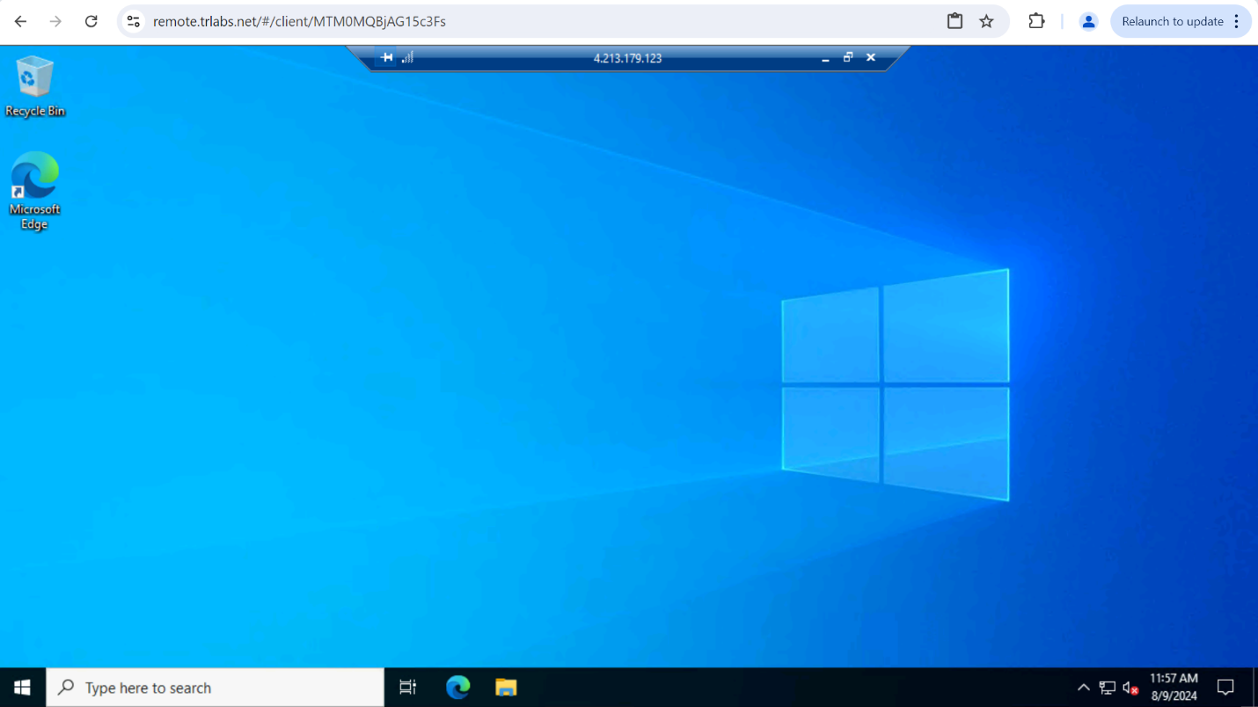

**4)Create a vm skillset for windows os where if the average CPU utilization is greater than 50, it should scale up and scale down.**

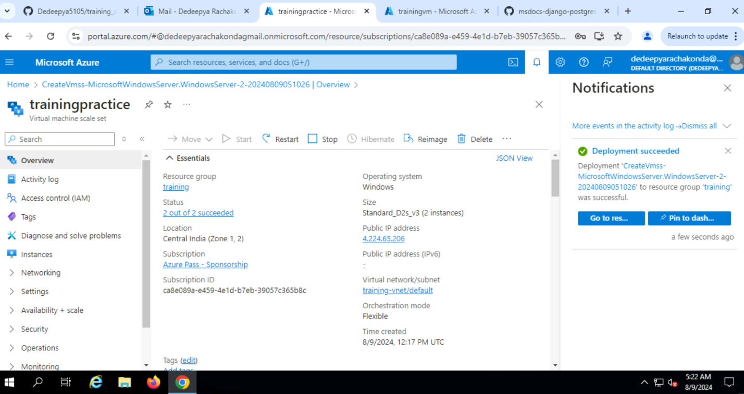

--- created a resource group

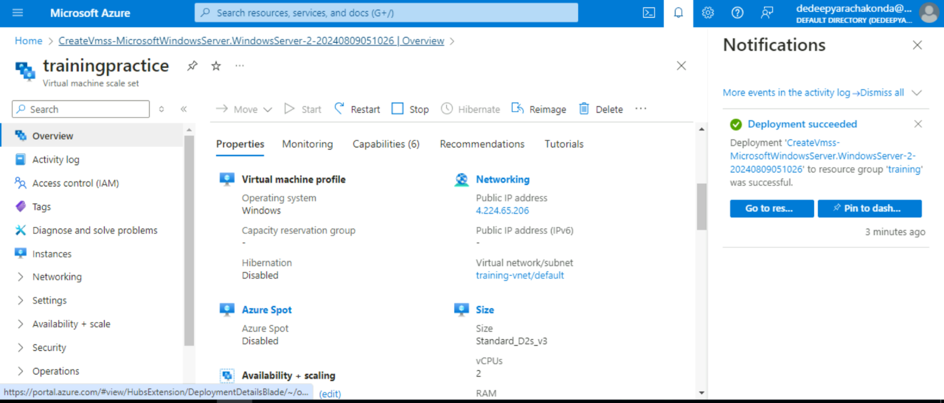

* During scale up, 2 instances present.

--- during scale down…only one instance present.

**5) Deploy spring pet clinic on azure app service.**

